Part Number: PT29A-12160-xx

Kit Contents

|  |  |  |
| --- | --- | --- |
| Item # | Quantity Reqd. | Description |
| 1 | 1 | Rear Spoiler |
| 2 | 2 | Hardware Bag |
|  |  |  |
|  |  |  |

Hardware Bag Contents

|  |  |  |
| --- | --- | --- |
| Item # | Quantity Reqd. | Description |
| 1 | 2 | M6 Assembly Nuts |
| 2 | 2 | Grommet Inserts |
| 3 | 1 | Hole Plug |
|  |  |  |

Additional Items Required For Installation

|  |  |  |
| --- | --- | --- |
| Item # | Quantity Reqd. | Description |
| 1 | 1 | Drill Template (PT29A-12160-TL) |
|  |  |  |
|  |  |  |
|  |  |  |

Conflicts

|  |
| --- |
|  |

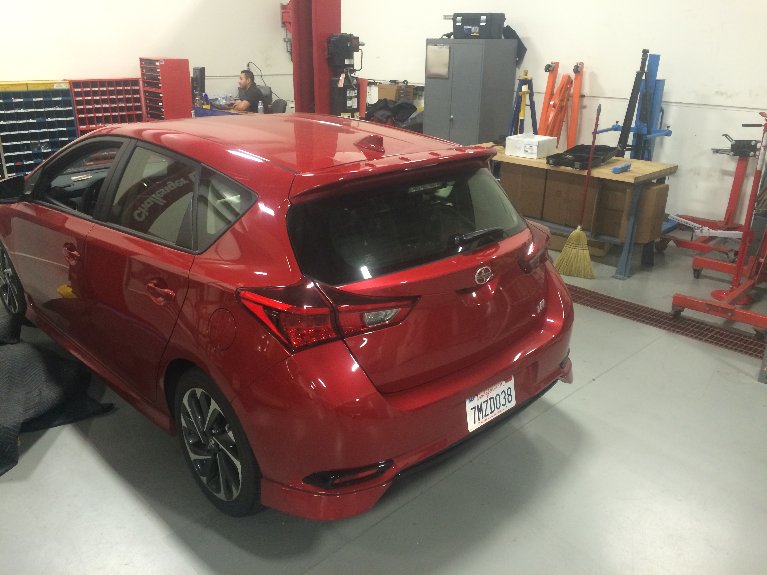Recommended Tools

|  |  |
| --- | --- |
| Personal & Vehicle Protection | Notes |
| Safety Glasses |  |
| Blankets |  |
| Masking Tape |  |
| Small Parts Tray |  |
| Special Tools | Notes |
|  |  |
| Installation Tools | Notes |
| Center punch |  |
| Drill Motor | ½” Chuck |
| Drill Bits | 3mm (1/8”), 9mm (23/64”), 14.5mm(9/16”) |
| Drill Stop | 19mm |
| Hole De-burring Tool |  |
| Ratchet |  |
| Socket and Extension | 8mm Deep Well/6” & 3” |
| Torque Wrench | 0-100 lbf•in |
| Panel Clip Removal Tool | Panel Pry Tool # 1 |
| Shop Vacuum |  |
| Hole Saw | 25mm (1”) |
| Special Chemicals | Notes |
| VDC Approved Cleaner |  |
| Sealant | 3M™ Ultra-Pro Body Sealant |

General Applicability

|  |
| --- |
| All iM Models |

Recommended Sequence of Application

|  |  |
| --- | --- |
| Item # | Accessory |
| 1 |  |
|  |  |
|  |  |
|  |  |

\*Mandatory

Vehicle Service Parts (may be required for reassembly)

|  |  |  |
| --- | --- | --- |
| Item # | Quantity Reqd. | Description |
| 1 | 1 | Hardware Bag (PT29A-12160-AB) |
| 2 | 1 |  |
| 3 | 1 |  |
|  |  |  |

Legend

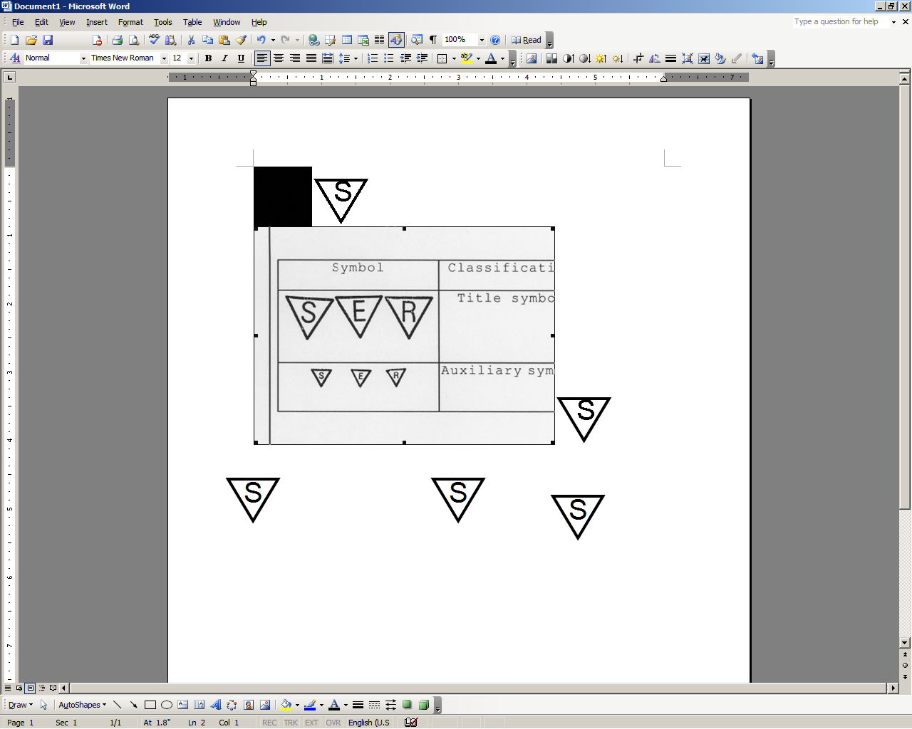

**STOP:** Damage to the vehicle may occur. Do not proceed until process has been complied with.

**OPERATOR SAFETY:** Use caution to avoid risk of injury.

**CAUTION:** A process that must be carefully observed in order to reduce the risk of damage to the accessory/vehicle and to ensure a quality installation.

**TOOLS & EQUIPMENT:** Used in Figures calls out the specific tools and equipment recommended for this process.

**REVISION MARK:** This mark highlights a change in installation with respect to previous issue.  
  
**SAFETY TORQUE:** This mark indicates that torque is related to safety.



Care must be taken when installing this accessory to ensure damage does not occur to the vehicle. The installation of this accessory should follow approved guidelines to ensure a quality installation.

These guidelines can be found in the "Accessory Installation Practices" document.

This document covers such items as:-

* Vehicle Protection (use of covers and blankets, cleaning chemicals, etc.).
* Safety (eye protection, rechecking torque procedure, etc.).
* Vehicle Disassembly/Reassembly (panel removal, part storage, etc.).
* Electrical Component Disassembly/Reassembly (battery disconnection, connector removal, etc.).

C:\Users\156331\AppData\Local\Microsoft\Windows\Temporary Internet Files\Content.Word\Protective Blankets.epsPlease see your Toyota dealer for a copy of this document.

Prepare the Vehicle.

* 1. Installation of the rear wind deflector should not take place until the following have been completed:  
     (1) The car is washed.  
     (2) The back door and rear wind deflector should be a minimum of 60˚F for proper set-up of adhesive tape. Use a hot air blower to heat the surface if the temperature is below 60˚F.

Fig. 1-1

* 1. 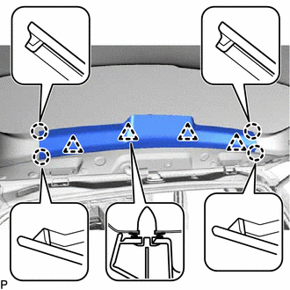Open the rear door and place blankets to protect the sheet metal. (Fig. 1-1).

##### toolRemove Trim Panel

* 1. caution_2Disengage the 4 claws and 4 clips, and remove the back door upper trim panel assembly. (Fig.2-1)
  2. Secure the exposed wire to the outside of the sheet metal with tape as shown in Fig. 2-2

C:\Users\156331\AppData\Local\Microsoft\Windows\Temporary Internet Files\Content.Word\Protective Tape 2.eps

Fig. 2-2

Fig. 2-1

Fig. 1-1

Fig. 1-2

##### Rear Wind Deflector Preparation

* 1. Align and tape the DIO installation template (part # PT29A-12160-TL) as per the printed directions. (Fig 3-1).

Fig. 3-1

tool

* 1. Center punch each of the four holes as per the holes located in the drill template (Fig. 2-2). Remove the template.

Fig. 3-2

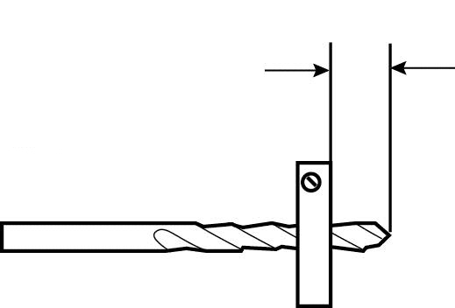

tool

* 1. Drill a 3mm pilot hole in each center punched location. Make sure that the drill bit is equipped with a drill stop set at 19mm. (Fig. 3-3)

##### safety_2CAUTION: Eye protection must be worn during all hole drilling.

Fig. 3-3

19mm

3mm (1/8”) Pilot

tool

* 1. Enlarge each drilled hole to the final sizes as identified on the DIO installation template as shown on Fig. 3-4. Make sure that the drill bit is equipped with a drill stop set at 19mm.

Fig. 3-4

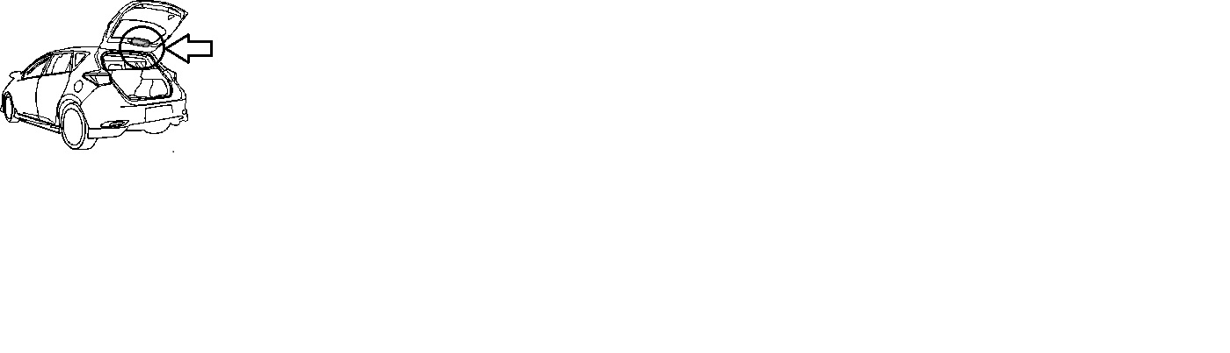

* 1. toolAlign and tape the access hole template (PT29A-12160-TEMP) onto the inside of the back door (passenger side only) as shown in Fig. 2-6. Center punch the hole as per the crosshairs in the template. Remove the template and drill the access hole with a 25mm (1”) hole saw. (Fig 3-5 & 3-6).

Fig. 3-5

stop_2**Note: Make sure the blankets fully cover the sheet metal below the backdrill hole location**

* 1. toolUsing a flexible magnet, remove any metal shavings from the inside of the door cavity. Deburr and apply 3M Ultra-Pro Body Sealant to the backdrilled hole. (Fig. 3-7).

C:\Users\156331\AppData\Local\Microsoft\Windows\Temporary Internet Files\Content.Word\Magnet Cleaning.eps

Fig. 3-6

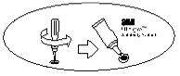

Fig. 3-7



* 1. toolUsing a deburring tool, remove any sharp edges on each of the four holes. Clean the surface of the deck lid where the spoiler attaches with a VDC approved cleaner and a lint free cloth. Apply 3M Ultra-Pro Body Sealant to the drilled holes. (Fig. 3-8)

Fig. 3-8



* 1. Insert the plastic grommets into the two outside (14mm) holes as shown in Fig. 3-9.

Fig. 3-9

C:\Users\156331\AppData\Local\Microsoft\Windows\Temporary Internet Files\Content.Word\Spoiler prep.eps

* 1. Remove the four tape liners from the rear wind deflector as shown in Fig. 3-10.

Remove

C:\Users\156331\AppData\Local\Microsoft\Windows\Temporary Internet Files\Content.Word\Spoiler prep.eps

Fig. 3-10

* 1. Peel back and tape the two remaining liners as shown in Fig. 3-11.

Peel back and tape tabs

##### stop_2NOTE: Once the release liner is removed from the molding, the surface of the foam tape must not be touched!

Fig. 3-11

##### C:\Users\156331\AppData\Local\Microsoft\Windows\Temporary Internet Files\Content.Word\Placing Spoiler 1.epsInstall Rear Wind Deflector

* 1. Install the rear wind deflector onto the back door by aligning the middle studs on the rear wind deflector to the drilled center holes on the back door. Place the rear wind deflector against the vehicle so that the rearmost surface and tape comes into contact with the sheet metal (Fig. 4-1.)

Fig. 4-1

* 1. C:\Users\156331\AppData\Local\Microsoft\Windows\Temporary Internet Files\Content.Word\Placing Spoiler 2.epsRotate the rear wind deflector into place on the vehicle making sure the outside studs engage onto the grommets in the holes. Remove remaining tape liners and install the rear wind deflector to the rear door by firmly pressing on all surfaces to ensure full contact. Note: the outside attachment locations will ratchet into place. (Fig. 4-2).

Fig. 4-2

C:\Users\156331\AppData\Local\Microsoft\Windows\Temporary Internet Files\Content.Word\Attaching Nuts.eps

* 1. Install the two M6 nuts onto the center studs and torque to 4 N.M (35 in.lb) Insert the plastic hole plug into the drilled hole and remove the tape securing the wire harness (Fig. 4-3).

Fig. 4-3

##### Reinstall inner panel

* 1. Engage the 4 claws and 4 clips and reinstall the back door upper trim panel assembly. (Fig.5-1)

Fig. 5-1

##### C:\Users\156331\AppData\Local\Microsoft\Windows\Temporary Internet Files\Content.Word\Spoiler Inspection.epsInspect the rear wind deflector.

* 1. caution_2Check the rear wind deflector for proper fitment.
  2. caution_2Ensure the rear wind deflector is centered left to right ± 3mm.
  3. caution_2Ensure all adhesive is properly adhered (maximum gap of 1.5mm).

Fig. 6-1

­

Accessory Function Checks

Verify acceptable gaps between spoiler attaching base and vehicle sheet metal

Vehicle Function Checks

Verify trunk lid operation

Verify CHMSL operation

When opened, the trunk lid should initially pop up fully and remain in the fully raised position.

Ensure light operation when pressing on brake pedal.

Vehicle Appearance Check

After accessory installation and removal of protective cover(s), perform a visual inspection.

Ensure no damage (including scuffs and scratches) was caused during the installation process.

(For PPO installations, refer to TMS Accessory Quality Shipping Standard.)